Patrick Homan Entry #1

Citation: Mark Bowden, “The Worst Problem on Earth,” *The Atlantic*, July/August 2017.

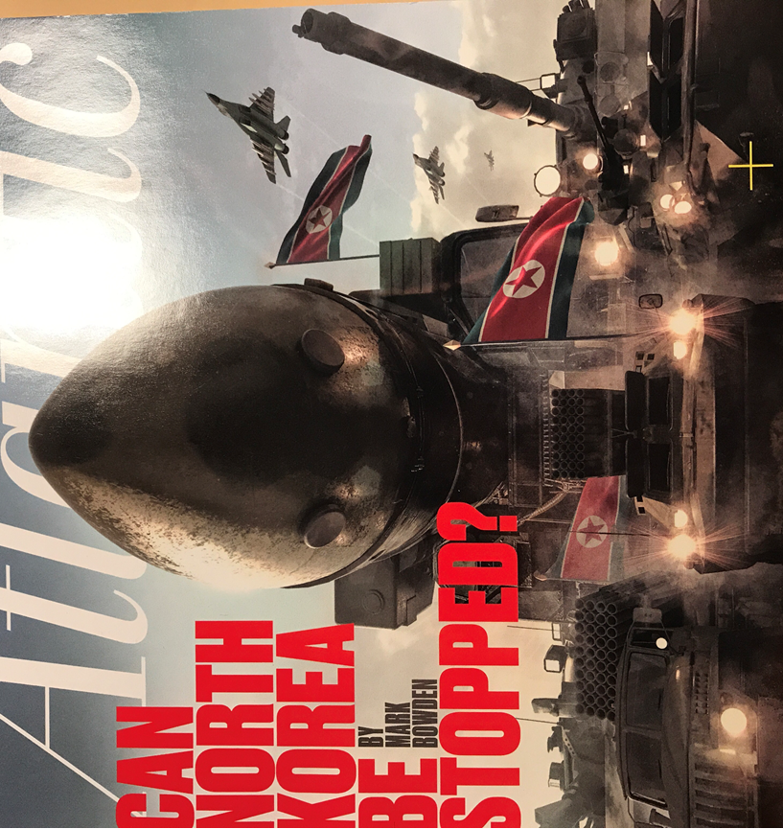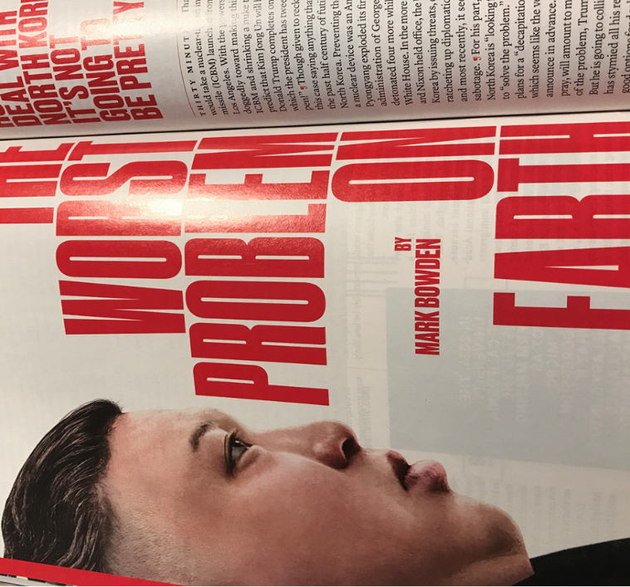

(you don’t need more than one picture)

Here is how you would do a podcast

Citation: “Are We Going to War with North Korea,” *Foreign Policy’s The ER*. August 11, 2017.

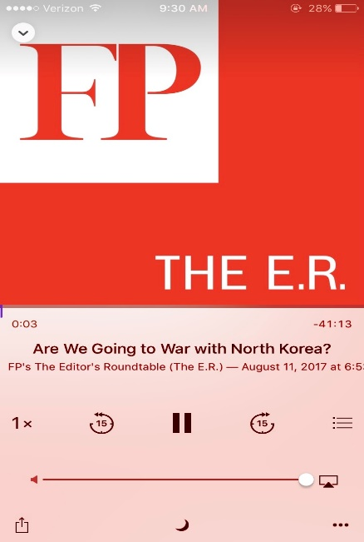

Analysis for entry #1

This week I read an article (and listened to a podcast) about the ongoing situation with North Korea and its development/testing of nuclear weapons. Over the past few months, North Korea has tested a number of missiles and nuclear weapons creating a level of uncertainty in the United States as well as some of its neighboring countries like Japan. The Trump administration’s response has been to push China, North Korea’s closest ally and patron, to pressure North Korea into better behavior. This article lays out a number of options of how to deal with the situation in North Korea. I can describe, explain, and predict using this event in a number of ways from what I have learned this semester in International Relations.

First, I can describe and explain this event using classic realism. From the realist perspective, the North Korean regime’s pursuit of nuclear weapons is only natural as the country tries seeks ‘self-help’ in order to have more security within an anarchical world. Having nuclear weapons gives North Korea more power, and therefore more safety. Since the end of the Korean War, North Korea has felt unsafe due to the American presence in South Korea. This is very similar to what we talked about in class with the security dilemma. The U.S. puts troops in Korea to make the South feel safe, but by doing so they make the North feel unsafe and spurs it to build weapons that makes it feel more secure.

Second, I can also predict something surrounding this event using what we learned during our chapter on war and ending war. One possible end to this conflict is acceptance, that the US and the West will have to be okay with North Korea’s nukes and that they only want to deter a future war. Hopefully, we can avoid an arms race where Japan and South Korea also start producing nuclear weapons. An arms control treaty would be one way that could possibly solve this problem, where states pledge to follow certain rules about their weapons development.